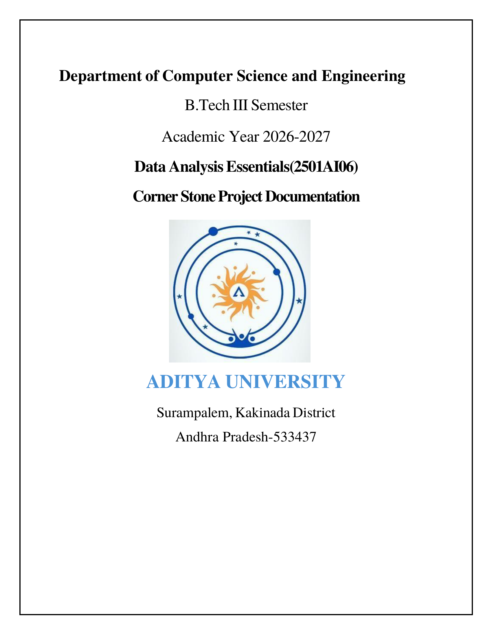

SCHOOL OF COMPUTING
Department of Computer Science and Engineering
DATA ANALYSIS ESSENTIALS
CORNERSTONE PROJECT REPORT
on
HUMAN RESOURCE RECRUITMENT ANALYSIS SYSTEM
Submitted by
V SUDEEPTHI (25B11CS979)
S S NAGGH JYOTI (25B11CS863)
A HARI CHARANI (25B11CS047)

Under the guidance of
K Vydehi
Assistant Professor, Department of CSE
ADITYA UNIVERSITY, Surampalem
Academic Year 2026-2027

SCHOOL OF COMPUTING

Department of Computer Science and Engineering

DATA ANALYSIS ESSENTIALS

CERTIFICATE

This is to certify that the Cornerstone project work entitled “Human Resource Recruitment Analysis System” is submitted by
V SUDEEPTHI | (25B11CS979)
S S NAGGH JYOTI | (25B11CS863)
A HARI CHARANI | (25B11CS047)

in partial fulfillment of the requirements for the award of the B.Tech. degree in Computer Science and Engineering for the academic year 2026-2027.

Project Guide Head of the Department
Mrs .K Vydehi, M.Tech.,(Ph.D) Dr. Phani Sridhar Addepalli, Ph.D,
Assistant Professor, Assistant Professor,
Department of CSE Department of CSE

DECLARATION

We hereby declare that the Cornerstone project entitled “Human Resource Recruitment Analysis System” is original and is submitted to ADITYA UNIVERSITY, Surampalem, in partial fulfillment of the requirements for the award of the B.Tech. Degree in Computer Science and Engineering. We further declare that this project work has not been submitted, either in full or in part, for the award of any degree in this or any other institution. We also confirm that this work complies with the Institutional Academic Integrity and AI Usage Policy

Place: Surampalem
Date:5-10-2026
By
V SUDEEPTHI | (25B11CS979)
S S NAGGH JYOTI | (25B11CS863)
A HARI CHARANI | (25B11CS047)

ACKNOWLEDGEMENT

It is with immense pleasure that we express our sincere gratitude to our Cornerstone Project Guide,
Mrs K Vydehi,M.Tech.,(Ph.D), Assistant Professor, who has guided us throughout the project. Her valuable support, encouragement, and guidance have greatly contributed to the successful completion of this work.
We would like to thank our Deputy Heads of the Department, Dr. Chandra Sekhar Kolli, Associate Professor, Dr Hari Jyothula, Associate Professor and Dr. Pennada Siva Satya Prasad, Assistant Professor, Department of Computer Science and Engineering, for their support and valuable suggestions.
Our deepest thanks to our Head of the Department Dr. Phani Sridhar Addepalli, Assistant Professor, for his inspiration and for providing all the necessary facilities and resources required for this project.
We also extend our sincere thanks to Dr. M.V. Rajesh, Associate Dean, School of Computing for their encouragement and support during the course of our project.
We would like to express our sincere gratitude to Dr. G. Suresh, Registrar, Dr. A Ramesh, Pro Vice-Chancellor (Engineering & Sciences), Dr. S. Rama Sree, Pro Vice-Chancellor (Academics), Dr. M.B. Srinivas, Vice-Chancellor, Dr. M. Sreenivasa Reddy, Deputy Pro Chancellor and Management, Aditya University for providing excellent infrastructure and state-of-the-art laboratories.
Finally, we would like to thank the faculty members, lab technicians, non-teaching staff, and our friends who have directly or indirectly supported us in completing this Cornerstone project successfully.

ABSTRACT
Human Resource (HR) recruitment is the process of identifying, evaluating and selecting suitable candidates for an organization. As the number of applicants grows, reviewing candidate records manually becomes slow, inconsistent and prone to human error. This project, the Human Resource Recruitment Analysis System, applies Python-based data analysis to bring speed, structure and objectivity to this process. The system uses a structured HR recruitment dataset of 1,000 candidate records stored in CSV format, with attributes such as qualification, experience, department, recruitment status and evaluation scores. The data is loaded into a Pandas DataFrame, inspected, and preprocessed by checking missing values, removing duplicate records, cleaning text columns, standardizing the Status field and encoding categorical attributes into numeric codes. The cleaned data is then analysed to study the distribution of candidates by qualification, filter experienced candidates (5 or more years of experience), and generate department-wise recruitment statistics. Matplotlib is used to visualize the results through a bar chart of selected candidates by department, a pie chart of qualification distribution and a histogram of experience distribution. Finally, candidates are ranked using the Final_Score attribute to identify the top performers. The analysis shows that the dataset is clean (no missing or duplicate records), that the candidate pool is balanced across eight qualifications and eight departments, and that 673 of the 1,000 candidates (67.3%) have five or more years of experience. The Sales department has the fewest candidates (100) and the fewest selections (41). The project demonstrates how data analytics can support fair, efficient and data-driven hiring decisions.

Table of contents
S.No. | Contents | Pages
1 | Title Page | 1
2 | Certificate | 2
3 | Declaration | 3
4 | Acknowledgement | 4
5 | Abstract | 5
6 | Table of Contents | 6
7 | List of Figures | 8
8 | List of Tables | 9
Chapter 1 | Introduction | 10
1.1 | Introduction to the Project | 10
1.2 | Problem Statement | 10
1.3 | Objectives of the Project | 10
1.4 | Scope of the Project | 11
Chapter 2 | Dataset Description and Understanding | 12
2.1 | Dataset Source | 12
2.2 | Dataset Description | 12
2.3 | Features / Attributes | 13
2.4 | Target Variable | 13
2.5 | Dataset Statistics / Initial Exploration | 14
Chapter 3 | Data Preprocessing | 15
3.1 | Data Collection / Loading | 15
3.2 | Handling Missing Values | 15
3.3 | Handling Duplicate / Inconsistent Data | 16
3.4 | Feature Scaling | 16
3.5 | Standardization | 16
3.6 | Label Encoding | 17
3.7 | One-Hot Encoding | 17
3.8 | Other Project-Specific Preprocessing | 17
Chapter 4 | System Design and Methodology | 18
4.1 | Proposed Methodology | 18
4.2 | System Workflow / Architecture | 18
4.3 | Flowchart | 19
4.4 | Tools and Technologies Used | 20
4.5 | Algorithm / Model Used | 21
Chapter 5 | Implementation | 22
5.1 | Development Environment | 22
5.2 | Dataset Loading and Exploration | 22
5.3 | Preprocessing Implementation | 22
5.4 | Exploratory Data Analysis (EDA) | 23
5.5 | Model / Analysis Implementation | 23
5.6 | Important Code Explanation | 24
Chapter 6 | Data Visualization and Results | 25
6.1 | Bar Graph | 25
6.2 | Pie Chart | 25
6.3 | Histogram | 26
6.4 | Box Plot | 27
6.5 | Line Chart | 27
6.6 | Scatter Plot | 27
6.7 | Project-Specific Visualizations | 27
6.8 | Interpretation of Visualizations | 27
Chapter 7 | Model Evaluation / Analysis of Results | 29
7.1 | Evaluation Metrics | 29
7.2 | Experimental Results | 29
7.3 | Result Interpretation | 30
7.4 | Discussion | 31
Chapter 8 | Output Screenshots | 32
8.1 | Input / Dataset Screenshots | 32
8.2 | Preprocessing Outputs | 32
8.3 | Visualization Outputs | 33
8.4 | Prediction / Analysis Outputs | 35
Chapter 9 | Conclusion and Future Enhancements | 37
9.1 | Conclusion | 37
9.2 | Limitations | 37
9.3 | Future Enhancements | 37
10 | References | 38
11 | Appendix – Source Code | 39

LIST OF FIGURES
Figure No. | Title of the Figure | Page No.
Figure 4.1 | Layered architecture of the Human Resource Recruitment Analysis System | 19
Figure 4.2 | Flowchart of the recruitment analysis process | 20
Figure 5.1 | Code for loading the dataset | 22
Figure 5.2 | Code for missing value, duplicate and data type checks | 23
Figure 5.3 | Code for the data transformation step | 23
Figure 6.1 | Selected candidates by department (bar chart) | 25
Figure 6.2 | Candidate qualification distribution (pie chart) | 26
Figure 6.3 | Candidate experience distribution (histogram) | 26
Figure 8.1 | Output of loading the dataset (first five records, shape and column names) | 32
Figure 8.2 | Missing value and duplicate record check | 32
Figure 8.3 | Output of data transformation (encoded columns added) | 33
Figure 8.4 | Bar chart output: selected candidates by department | 33
Figure 8.5 | Pie chart output: qualification distribution | 34
Figure 8.6 | Histogram output: experience distribution | 34
Figure 8.7 | Candidate qualification analysis output | 35
Figure 8.8 | Experience-wise filtering output (673 candidates) | 35
Figure 8.9 | Department-wise recruitment statistics output | 36

LIST OF TABLES
Table No. | Title of the Table
Table 2.1 | Attributes of the recruitment dataset | 13
Table 2.2 | First five records of the dataset | 13
Table 2.3 | Summary statistics of Experience and Final_Score | 14
Table 3.1 | Missing value count for each attribute | 16
Table 3.2 | Label-encoding scheme used for categorical attributes | 17
Table 4.1 | Tools and technologies used | 20
Table 5.1 | Development environment | 22
Table 5.2 | Important code and its explanation | 24
Table 6.1 | Top 10 candidates ranked by Final_Score | 27
Table 7.1 | Candidates by qualification | 29
Table 7.2 | Department-wise candidates and selected candidates | 30
Table 7.3 | Summary of analysis results | 30

CHAPTER 1

INTRODUCTION

1.1 Introduction to the Project
Human Resource (HR) recruitment is the process of identifying, attracting, evaluating and selecting suitable candidates for an organization. The quality of recruitment decisions directly influences workforce quality, team performance and the long-term productivity of the organization. In today's competitive environment, companies receive a very large number of applications for every open position, and each application carries information such as educational qualification, years of experience, the department applied for and various evaluation scores.
Reviewing such data manually is slow, inconsistent and prone to error. Data analytics offers a structured and objective alternative. By loading the recruitment records into a tabular structure, cleaning them, summarizing them and visualizing them, recruiters can quickly understand who is applying, where the strengths of the candidate pool lie and which candidates deserve priority.
The Human Resource Recruitment Analysis System is a Python-based data analysis project developed for the Data Analysis Essentials (DAE) course. It uses the Pandas library for data handling and the Matplotlib library for visualization to analyse a dataset of 1,000 candidate records and to rank candidates using their evaluation scores.

1.2 Problem Statement
Recruiters must review large volumes of candidate data, such as qualification, experience and department, before taking a hiring decision. Manual analysis of this data is time-consuming and is vulnerable to human error and unconscious bias. In the absence of a structured system, it is difficult to compare candidates objectively or to see recruitment trends across departments and qualification levels.
There is therefore a clear need for a systematic, automated approach that can organize recruitment data, clean it, analyse it and present the results in an easily understandable form, so that hiring decisions can be supported by facts rather than by intuition alone.

1.3 Objectives of the Project
The main objectives of the project are:
- To import and organize recruitment data using Python and the Pandas library.
- To preprocess the data by handling missing values and duplicate records and by cleaning and encoding the attributes.
- To analyse recruitment trends across departments, qualifications and experience levels.
- To visualize key insights using bar charts, pie charts and histograms.
- To rank candidates based on their evaluation scores to support data-driven hiring decisions.

1.4 Scope of the Project
The scope of this project covers the complete descriptive analysis workflow on a single recruitment dataset: data loading, data inspection, preprocessing, qualification analysis, experience-based filtering, department-wise statistics, graphical visualization and score-based candidate ranking. The analysis is carried out on a static CSV file containing 1,000 candidate records with 10 attributes.
The project does not build a predictive machine-learning model and does not read live data from an applicant tracking system. These points are identified as limitations and future enhancements in Chapter 9.
CHAPTER 2

DATASET DESCRIPTION AND UNDERSTANDING

2.1 Dataset Source
A structured HR recruitment dataset containing 1,000 candidate records was selected for the project. The dataset was obtained as a compressed archive (archive (6).zip) which contains the CSV file HR_Recruitment_1000_Candidates.csv. The file is read directly into Python using the Pandas library.
The dataset was selected because it is stored in CSV format, which is easy to process with Python and Pandas, and because it provides enough records and attributes to perform candidate analysis, filtering, recruitment statistics and visualization. It also contains evaluation scores, which make the candidate ranking enhancement possible.

2.2 Dataset Description
The dataset describes 1,000 candidates who applied to different departments of an organization. Each row represents one candidate and each column represents one property of that candidate. The dataset contains information about the candidate's identity, educational qualification, professional experience, the department associated with the candidate, the recruitment status and four evaluation scores (education, interview, skills and final score).
The dataset has a shape of (1000, 10), that is, 1,000 rows and 10 columns. Five columns hold text (object) values, four hold integer values and one holds decimal (float) values. After the transformation step of Chapter 3, three numeric code columns are added, making 13 columns in total.

2.3 Features / Attributes
Table 2.1: Attributes of the recruitment dataset
S.No. | Attribute | Data Type | Description
1 | Candidate_ID | object | Unique identifier of the candidate
2 | Name | object | Candidate name
3 | Qualification | object | Educational qualification
4 | Experience | int64 | Years of professional experience
5 | Department | object | Department associated with the candidate
6 | Status | object | Recruitment status (Selected / Rejected / Under Review)
7 | Education_Score | int64 | Score based on education
8 | Interview_Score | int64 | Interview evaluation score
9 | Skills_Score | int64 | Skills evaluation score
10 | Final_Score | float64 | Overall evaluation score

The first five records of the dataset are shown in Table 2.2 to give an idea of the values stored in each attribute.
Table 2.2: First five records of the dataset
ID | Name | Qualification | Exp. | Department | Status | Edu. | Int. | Skills | Final
C0001 | Ravi Sinha | MBA | 9 | HR | Under Review | 78 | 98 | 63 | 81.5
C0002 | Varun Das | B.Sc | 9 | Data Analytics | Rejected | 96 | 95 | 88 | 93.2
C0003 | Ramesh Chowdhury | M.Sc | 14 | Finance | Selected | 96 | 67 | 61 | 73.9
C0004 | Karthik Chowdhury | B.Tech | 6 | Marketing | Rejected | 65 | 49 | 58 | 56.5
C0005 | Sakshi Sharma | M.Sc | 13 | Finance | Selected | 65 | 74 | 55 | 65.6

2.4 Target Variable
Status is the target variable used to evaluate recruitment outcomes. It records whether a candidate has been *Selected*, *Rejected* or is still *Under Review*. The department-wise analysis of selected candidates in this project is based on this attribute. The Final_Score attribute is used as the basis for ranking candidates.

2.5 Dataset Statistics / Initial Exploration
The summary statistics produced by the describe() function for the two key numeric attributes, Experience and Final_Score, are given in Table 2.3.
Table 2.3: Summary statistics of Experience and Final_Score
Statistic | Experience (years) | Final_Score
count | 1000 | 1000
mean | 7.357 | 74.6116
std | 4.6066 | 8.8480
min | 0 | 52.1
25% | 3 | 68.2
50% (median) | 7 | 74.6
75% | 11 | 81.2
max | 15 | 97.3

Candidates have between 0 and 15 years of experience, with an average of about 7.4 years. Final scores range from 52.1 to 97.3 with an average of about 74.6, and half of all candidates score between 68.2 and 81.2. No value lies outside the expected range of either attribute.
CHAPTER 3

DATA PREPROCESSING
Raw data is rarely ready for analysis. Preprocessing ensures that the dataset is accurate, consistent and reliable before any analysis or visualization is performed. This chapter describes each preprocessing step considered for the project and states clearly whether it was required.

3.1 Data Collection / Loading
Recruitment data is imported from the CSV file using the Pandas read_csv() function. The data is stored in a DataFrame, which provides a structured, tabular format for analysis. Initial inspection is carried out using head(), shape and columns to make sure the dataset is correctly loaded before cleaning begins. The code and output for this step are shown in Figure 5.1 and Figure 8.1.
import pandas as pd

# Load the recruitment dataset
df = pd.read_csv("HR_Recruitment_1000_Candidates.csv")

# Display the first five records
print(df.head())

# Check dataset size
print("Dataset Shape:", df.shape)

The dataset loaded successfully with a shape of (1000, 10), confirming 1,000 candidates and 10 attributes.

3.2 Handling Missing Values
Missing values are identified using df.isnull().sum(). They can be handled either by removing the affected rows or by imputing suitable values. In this dataset every column contains 1,000 non-null values, so no missing value treatment was required.
Table 3.1: Missing value count for each attribute
Attribute | Missing values
Candidate_ID | 0
Name | 0
Qualification | 0
Experience | 0
Department | 0
Status | 0
Education_Score | 0
Interview_Score | 0
Skills_Score | 0
Final_Score | 0

3.3 Handling Duplicate / Inconsistent Data
Duplicate candidate records can skew results, so they are detected with df.duplicated().sum() and removed with drop_duplicates(). The check reported 0 duplicate records, and the dataset shape remained (1000, 10) after the removal step.
Inconsistent text formatting was handled in the transformation step. Extra leading and trailing spaces were removed from the Qualification, Department and Status columns using str.strip(), and the Status column was standardized to title case using str.title(), so that values such as "selected" and "Selected" are treated as the same category.
# Data Transformation
df["Qualification"] = df["Qualification"].str.strip()
df["Department"] = df["Department"].str.strip()
df["Status"] = df["Status"].str.strip().str.title()

3.4 Feature Scaling
Feature scaling (for example Min-Max scaling) is needed when numeric attributes with very different ranges are given to distance-based or gradient-based machine-learning algorithms. This project performs descriptive analysis, filtering, visualization and sorting only, and the score attributes are already on a comparable scale. Feature scaling was therefore not required in this project.

3.5 Standardization
Standardization (Z-score scaling) rescales an attribute to zero mean and unit variance and is mainly used before model training. Since no model is trained in this project and all comparisons are made on the original score values, standardization was not applied.

3.6 Label Encoding
The categorical attributes Qualification, Department and Status were encoded into numeric codes so that the dataset is ready for further analysis and modelling. Three new columns, Qualification_Code, Department_Code and Status_Code, were added. The codes follow the alphabetical order of the categories (as seen in the output of the transformation step).
Table 3.2: Label-encoding scheme used for categorical attributes
Attribute | Code : Category
Qualification_Code | 0 : B.Sc, 1 : B.Tech, 2 : BBA, 3 : BCA, 4 : M.Sc, 5 : M.Tech, 6 : MBA, 7 : MCA
Department_Code | 0 : Data Analytics, 1 : Finance, 2 : HR, 3 : IT, 4 : Marketing, 5 : Operations, 6 : R&D, 7 : Sales
Status_Code | 0 : Rejected, 1 : Selected, 2 : Under Review

3.7 One-Hot Encoding
One-hot encoding creates a separate binary column for every category and is used when a model must not interpret category codes as ordered numbers. Because the numeric codes in this project are used only for organization and no model is trained, one-hot encoding was not applied.

3.8 Other Project-Specific Preprocessing
Outliers in the numerical attributes, Experience and Final_Score, were examined through the summary statistics in Table 2.3. Experience lies between 0 and 15 years and Final_Score between 52.1 and 97.3, so no extreme or invalid values were found that could distort the results.
After preprocessing, the dataset contains 13 columns (10 original columns plus the 3 encoded columns) and is ready for analysis. The transformation output is shown in Figure 8.3.
CHAPTER 4

SYSTEM DESIGN AND METHODOLOGY

4.1 Proposed Methodology
The proposed system follows a step-by-step data analysis methodology. Each step takes the output of the previous step as its input.
- Data collection: the recruitment CSV file is loaded into a Pandas DataFrame.
- Data inspection: the first records, shape and structure of the data are displayed.
- Data preprocessing: missing values and duplicates are checked, text columns are cleaned and categorical attributes are encoded.
- Analysis: candidates are grouped by qualification and department, and experienced candidates are filtered.
- Visualization: results are presented as a bar chart, a pie chart and a histogram.
- Ranking: candidates are sorted by Final_Score to obtain the top performers.

4.2 System Workflow / Architecture
The system is organized into five layers, as shown in Figure 4.1. The data layer holds the CSV file; the preprocessing layer prepares the data; the analysis layer produces statistics and rankings; the visualization layer draws the charts; and the output layer presents the final insights to the recruiter.
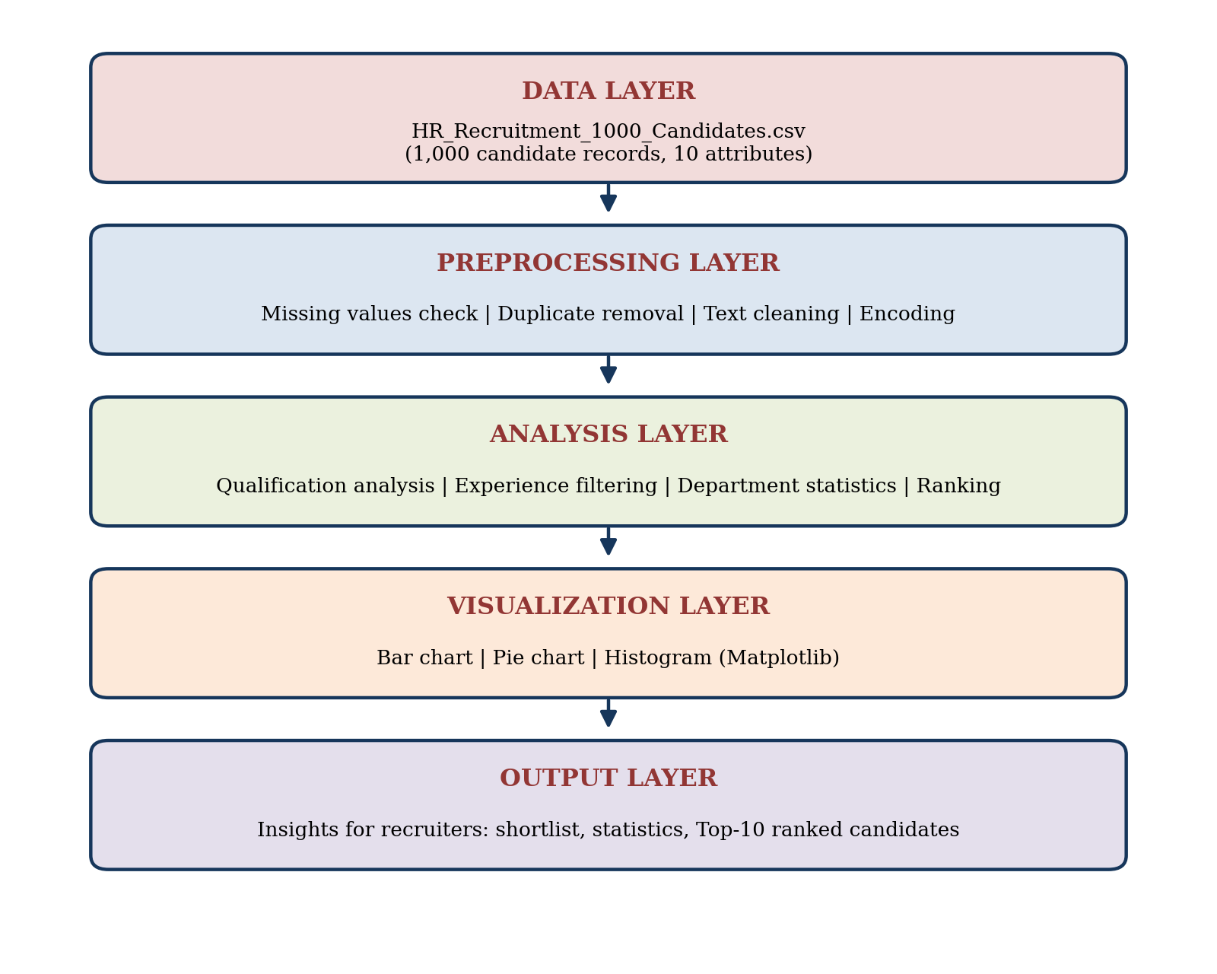
Figure 4.1: Layered architecture of the Human Resource Recruitment Analysis System

4.3 Flowchart
Figure 4.2 shows the flow of control of the project from loading the dataset to producing the final ranked list.
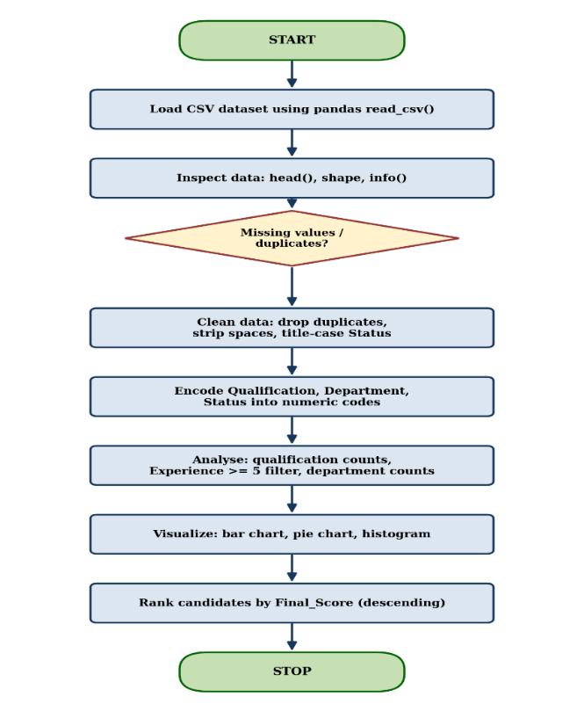
4.4 Tools and Technologies Used
Table 4.1: Tools and technologies used
S.No. | Tool / Technology | Purpose
1 | Python 3 | Programming language used for the complete implementation
2 | Pandas | Loading the CSV file, cleaning, filtering, grouping and sorting the data
3 | Matplotlib | Creating the bar chart, pie chart and histogram
4 | Jupyter / Google Colab Notebook | Environment used to write, run and display the code and its outputs
5 | CSV file format | Storage format of the recruitment dataset

4.5 Algorithm / Model Used
This project performs descriptive data analysis and does not use a machine-learning model. The following basic algorithms and operations are used:
- Frequency counting (value_counts) to count candidates by qualification, by department and by selected status.
- Boolean filtering (df[df["Experience"] >= 5]) to shortlist experienced candidates.
- Sorting (sort_values by Final_Score in descending order) to rank candidates.
- Descriptive statistics (describe) to summarize Experience and Final_Score.
Algorithm: Candidate ranking
Step 1: Load the cleaned DataFrame.
Step 2: Select the Final_Score column as the ranking criterion.
Step 3: Sort all candidate records by Final_Score in descending order.
Step 4: Select the required columns (Candidate_ID, Name, Qualification, Experience, Department, Final_Score, Status).
Step 5: Display the first 10 rows as the top 10 candidates.
CHAPTER 5

IMPLEMENTATION

5.1 Development Environment
Table 5.1: Development environment
Component | Details
Programming language | Python 3
Libraries | Pandas, Matplotlib
Environment | Jupyter / Google Colab notebook (DAE_REVIEW.ipynb)
Dataset | HR_Recruitment_1000_Candidates.csv (1,000 records, 10 attributes)
Operating system | Windows / any system with a web browser

5.2 Dataset Loading and Exploration
The dataset is loaded with pd.read_csv() and explored with head(), shape, len() and the columns attribute. This confirms the number of candidates (1,000) and the number of attributes (10).
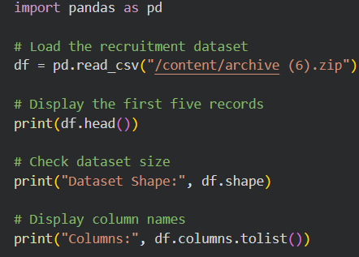
Figure 5.1: Code for loading the dataset

5.3 Preprocessing Implementation
Missing values are checked with isnull().sum(), duplicates with duplicated().sum(), and the structure of the data with df.info(). Duplicates are removed with drop_duplicates(). The text columns are cleaned and the categorical columns are encoded in the transformation step.
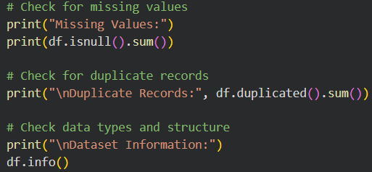
Figure 5.2: Code for missing value, duplicate and data type checks
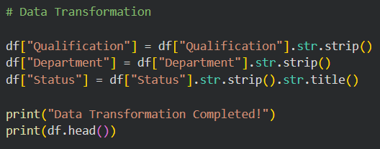
Figure 5.3: Code for the data transformation step

5.4 Exploratory Data Analysis (EDA)
Exploratory analysis is carried out in three parts: qualification analysis, experience-wise filtering and department-wise statistics.
Qualification analysis
qualification_counts = df["Qualification"].value_counts()
print(qualification_counts)

Experience-wise filtering
experienced_candidates = df[df["Experience"] >= 5]
print("Number of candidates:", len(experienced_candidates))

Department-wise statistics
department_counts = df["Department"].value_counts()
print(department_counts)

5.5 Model / Analysis Implementation
No predictive model is used. The analysis implementation consists of selecting the candidates whose status is Selected, counting them department-wise, drawing the charts, and ranking candidates by Final_Score.
selected_candidates = df[df["Status"] == "Selected"]
selected_by_department = selected_candidates["Department"].value_counts()

ranked_candidates = df.sort_values(by="Final_Score", ascending=False)
print(ranked_candidates.head(10))

5.6 Important Code Explanation
Table 5.2: Important code and its explanation
Code | Explanation
pd.read_csv() | Reads the CSV file and creates a DataFrame.
df.isnull().sum() | Counts missing values in each column.
df.duplicated().sum() | Counts fully duplicated rows.
df.drop_duplicates() | Removes duplicate rows to avoid skewed results.
str.strip() / str.title() | Removes extra spaces and standardizes text case.
value_counts() | Counts how many times each category occurs.
df[df["Experience"] >= 5] | Keeps only rows that satisfy the experience condition.
plot(kind="bar") | Draws a bar chart from a Pandas Series.
plt.pie() | Draws a pie chart with percentage labels (autopct).
plt.hist(bins=16) | Draws a histogram of experience with 16 bins.
sort_values(ascending=False) | Sorts candidates from highest to lowest Final_Score.

CHAPTER 6

DATA VISUALIZATION AND RESULTS
Visualization converts numerical results into pictures that can be understood at a glance. Three charts were created with Matplotlib for this project.

6.1 Bar Graph
The bar graph in Figure 6.1 shows the number of candidates with Selected status in each department.
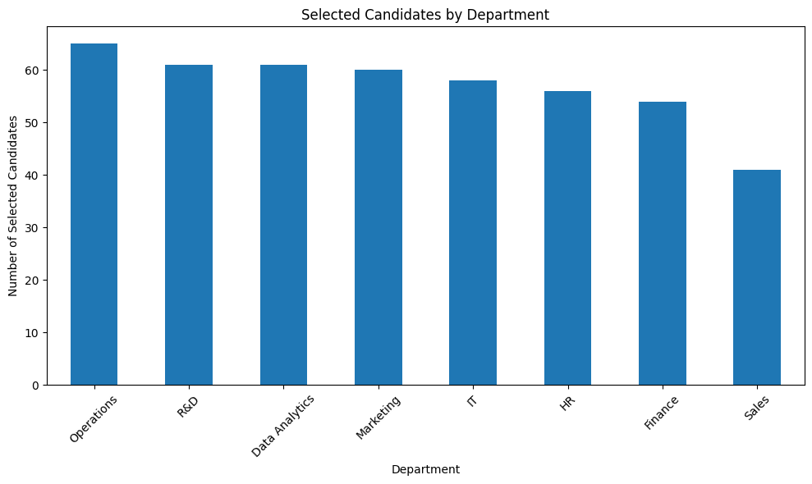
Figure 6.1: Selected candidates by department (bar chart)

6.2 Pie Chart
The pie chart in Figure 6.2 shows the share of candidates in each of the eight qualifications.
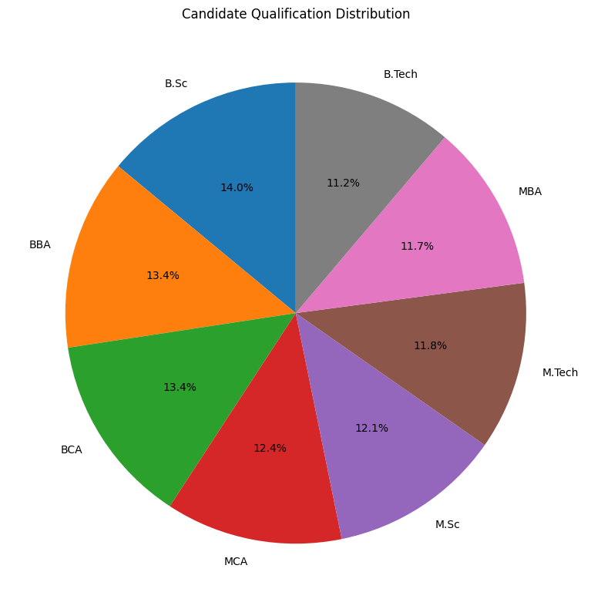
Figure 6.2: Candidate qualification distribution (pie chart)

6.3 Histogram
The histogram in Figure 6.3 shows how candidates are distributed across years of experience (16 bins, from 0 to 15 years).
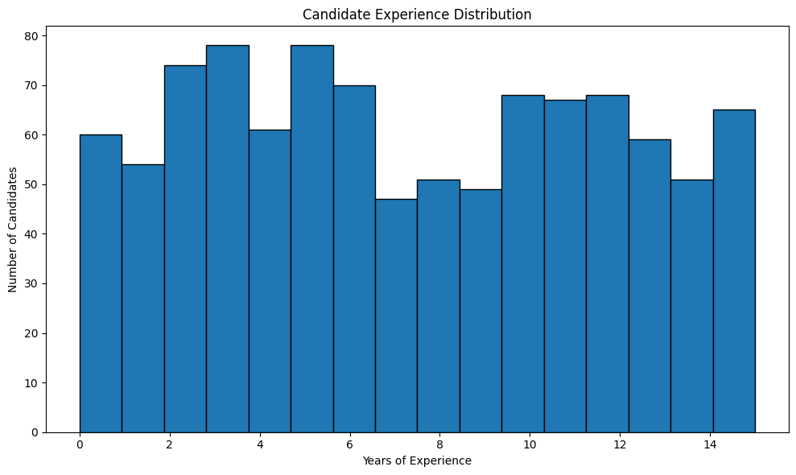
Figure 6.3: Candidate experience distribution (histogram)

6.4 Box Plot
A box plot was not part of the implemented analysis. It is proposed as a future enhancement to compare the spread of Final_Score across departments (see Section 9.3).

6.5 Line Chart
A line chart is normally used for time-based trends. The dataset has no date or time attribute, so a line chart was not applicable to this project.

6.6 Scatter Plot
A scatter plot was not part of the implemented analysis. It is proposed as a future enhancement to study the relationship between Experience and Final_Score (see Section 9.3).

6.7 Project-Specific Visualizations
The project-specific result is the candidate ranking table. Candidates were sorted by Final_Score, and the top 10 are listed in Table 6.1.
Table 6.1: Top 10 candidates ranked by Final_Score
Rank | ID | Name | Qual. | Exp. | Department | Final Score | Status
1 | C0265 | Surya Mishra | MBA | 15 | Data Analytics | 97.3 | Selected
2 | C0998 | Krishna Reddy | MCA | 6 | HR | 95.6 | Under Review
3 | C0617 | Sameer Malhotra | MCA | 2 | HR | 95.2 | Selected
4 | C0354 | Abhinav Saxena | MCA | 14 | Marketing | 95.1 | Selected
5 | C0843 | Kiran Saxena | MCA | 7 | Marketing | 94.8 | Selected
6 | C0968 | Priya Malhotra | B.Tech | 5 | R&D | 94.5 | Under Review
7 | C0994 | Krishna Sinha | M.Tech | 3 | Marketing | 94.1 | Selected
8 | C0589 | Rakesh Desai | B.Tech | 11 | Finance | 94.0 | Under Review
9 | C0118 | Meera Pillai | MBA | 8 | IT | 93.8 | Selected
10 | C0002 | Varun Das | B.Sc | 9 | Data Analytics | 93.2 | Rejected

6.8 Interpretation of Visualizations
- Bar chart: Operations has the most selected candidates (65), followed by R&D and Data Analytics (61 each). Sales has clearly the fewest (41).
- Pie chart: all eight qualifications have a similar share, from 11.2% (B.Tech) to 14.0% (B.Sc), so the candidate pool is well balanced.
- Histogram: candidates are spread across the whole 0 to 15 year range without one dominant group. The tallest bars are in the 3 to 6 year range, with roughly 70 to 78 candidates each, and the lowest bars are around 7 to 9 years.
- Ranking table: six of the top ten candidates are Selected, three are Under Review and one (C0002) is Rejected, so Final_Score alone does not decide the recruitment status.
CHAPTER 7

MODEL EVALUATION / ANALYSIS OF RESULTS

7.1 Evaluation Metrics
Because this is a descriptive analysis project and not a prediction model, accuracy, precision or recall are not applicable. The results are instead evaluated using the following analysis metrics: candidate counts, percentage share, mean, median and standard deviation of the numeric attributes, selection counts per department, and the Final_Score based ranking.

7.2 Experimental Results
Candidates by qualification
Table 7.1: Candidates by qualification
Qualification | Candidates | Share (%)
B.Sc | 140 | 14.0
BBA | 134 | 13.4
BCA | 134 | 13.4
MCA | 124 | 12.4
M.Sc | 121 | 12.1
M.Tech | 118 | 11.8
MBA | 117 | 11.7
B.Tech | 112 | 11.2
Total | 1000 | 100.0

Undergraduate qualifications (B.Sc, BBA, BCA, B.Tech) account for 520 candidates (52%) and postgraduate qualifications (MCA, M.Sc, M.Tech, MBA) for 480 candidates (48%).
Experience-wise filtering
With the filter Experience >= 5 years, 673 out of 1,000 candidates (67.3%) were found. The filtered table keeps all 10 columns and is useful for quickly shortlisting experienced candidates.
Department-wise statistics
Table 7.2: Department-wise candidates and selected candidates
Department | Candidates | Selected | Selection rate (%)
Data Analytics | 138 | 61 | 44.2
R&D | 134 | 61 | 45.5
Operations | 133 | 65 | 48.9
IT | 127 | 58 | 45.7
Marketing | 125 | 60 | 48.0
HR | 123 | 56 | 45.5
Finance | 120 | 54 | 45.0
Sales | 100 | 41 | 41.0
Total | 1000 | 456 | 45.6

The selection rate is the number of selected candidates divided by the number of candidates in that department; the totals are obtained by adding the department values.
Summary of results
Table 7.3: Summary of analysis results
Measure | Result
Total candidates analysed | 1,000
Attributes (original / after encoding) | 10 / 13
Missing values | 0
Duplicate records | 0
Most common qualification | B.Sc (140)
Least common qualification | B.Tech (112)
Candidates with 5 or more years of experience | 673 (67.3%)
Department with most candidates | Data Analytics (138)
Department with fewest candidates | Sales (100)
Average experience | 7.36 years
Average Final_Score | 74.61
Highest Final_Score | 97.3 (C0265, Surya Mishra)

7.3 Result Interpretation
The dataset is clean: no missing values and no duplicate records were found, so the analysis is based on all 1,000 records. The candidate pool is balanced across eight qualifications and eight departments, which means that no single qualification or department dominates the recruitment data. Two thirds of the candidates are experienced (5 or more years), which gives recruiters a large pool to shortlist from.
Sales has the fewest candidates (100) and also the fewest selections (41, a selection rate of 41.0%), so it may need extra recruitment focus. Operations has the highest selection rate (48.9%).

7.4 Discussion
The project shows that a few lines of Pandas and Matplotlib code can replace hours of manual reviewing. Counting, filtering, charting and ranking give recruiters an objective, repeatable view of the candidate pool. The ranking also reveals that a few high-scoring candidates are still Under Review or Rejected, which suggests that recruiters use factors other than Final_Score, and this is a useful point for further study. The results depend on the quality and representativeness of the given dataset.
CHAPTER 8

OUTPUT SCREENSHOTS

8.1 Input / Dataset Screenshots
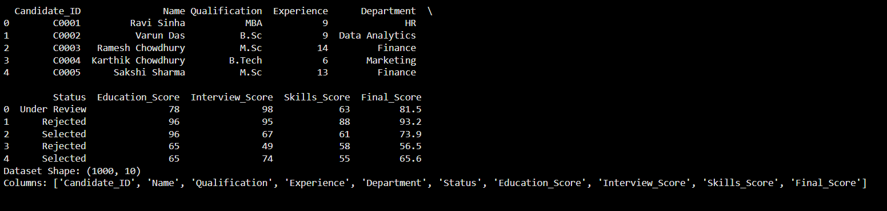
Figure 8.1: Output of loading the dataset (first five records, shape and column names)

8.2 Preprocessing Outputs
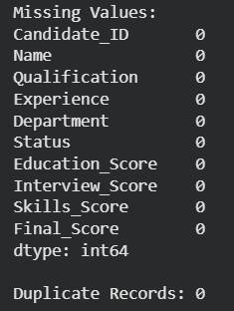
Figure 8.2: Missing value and duplicate record check
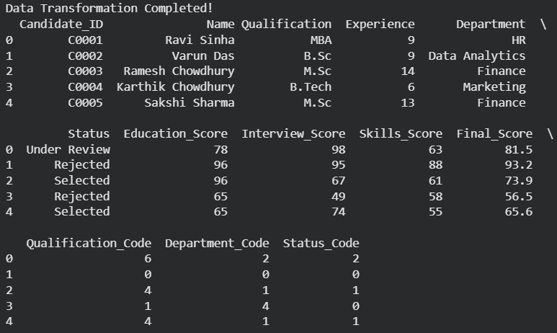
Figure 8.3: Output of data transformation (encoded columns added)

8.3 Visualization Outputs
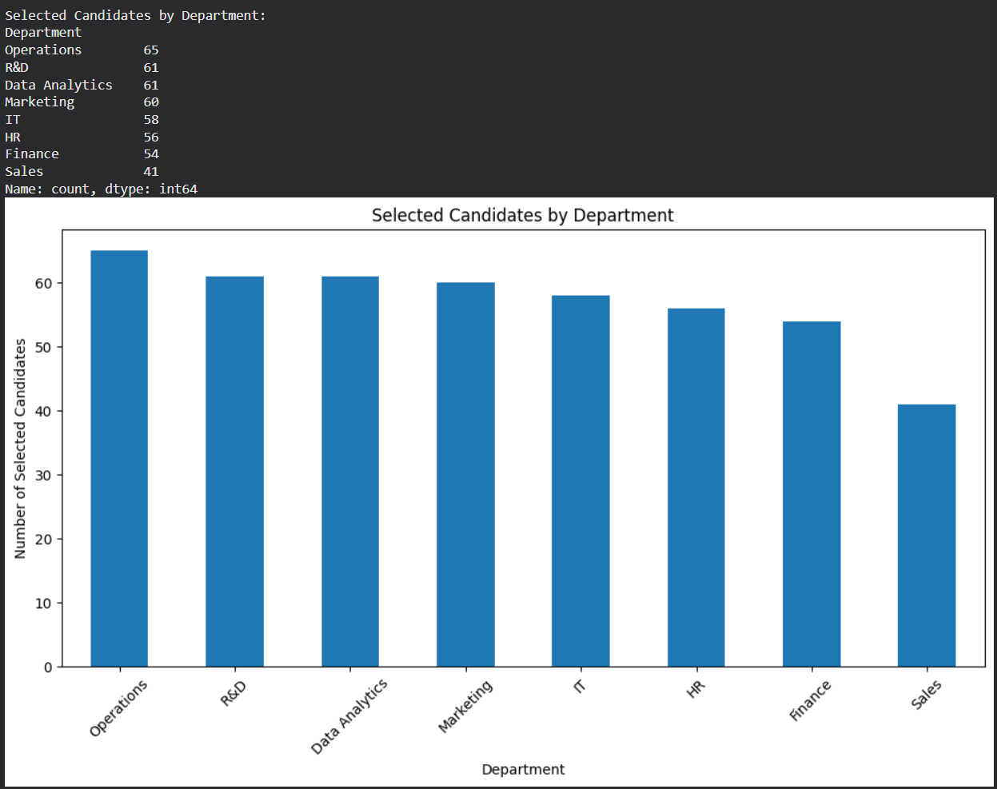
Figure 8.4: Bar chart output: selected candidates by department
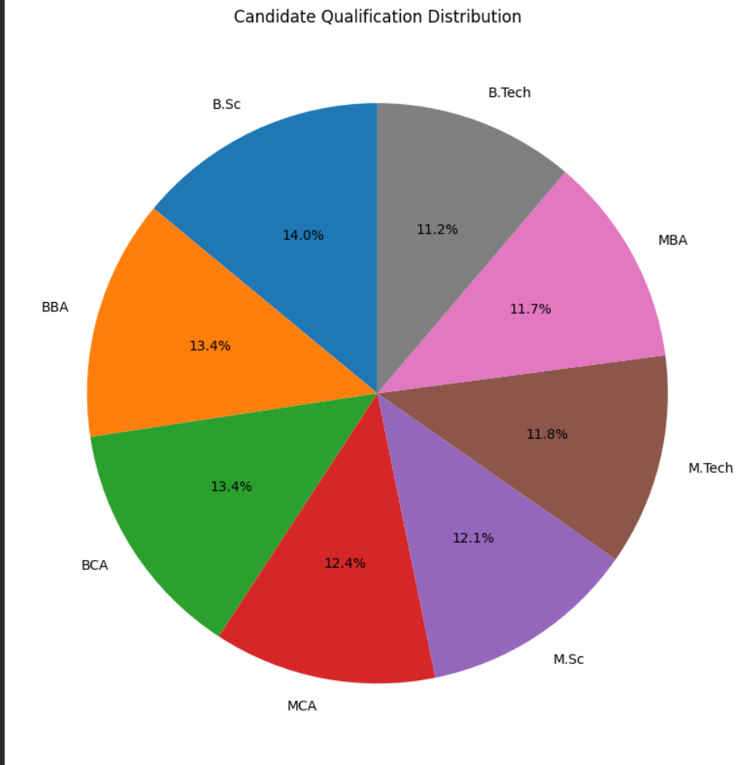
Figure 8.5: Pie chart output: qualification distribution
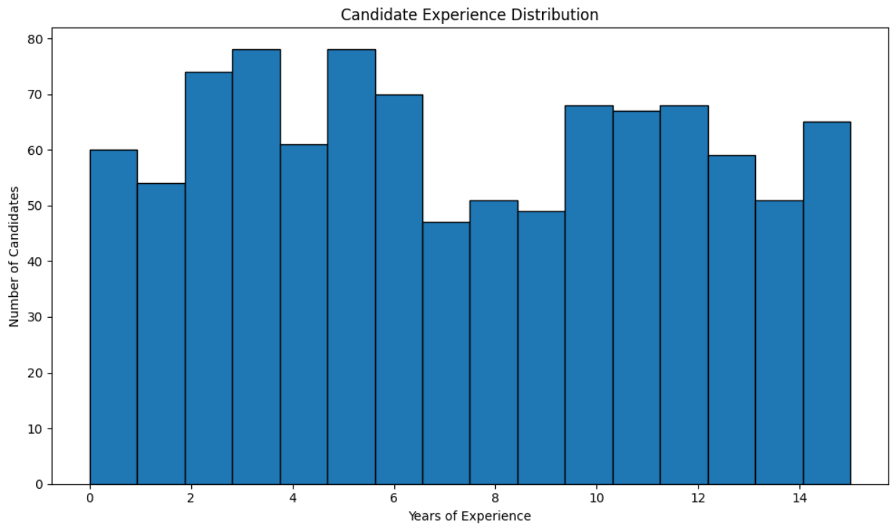
Figure 8.6: Histogram output: experience distribution

8.4 Prediction / Analysis Outputs
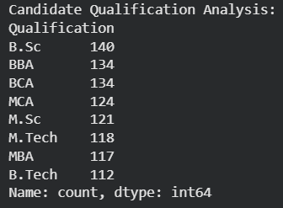
Figure 8.7: Candidate qualification analysis output
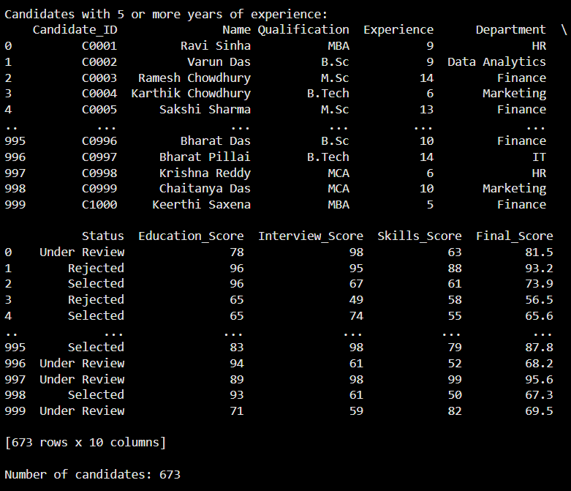
Figure 8.8: Experience-wise filtering output (673 candidates)
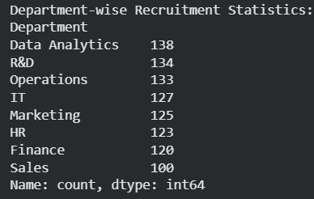
Figure 8.9: Department-wise recruitment statistics output
The top 10 ranked candidates produced by the ranking step are listed in Table 6.1.
CHAPTER 9

CONCLUSION AND FUTURE ENHANCEMENTS

9.1 Conclusion
The Human Resource Recruitment Analysis System successfully analysed a dataset of 1,000 candidates using Python, Pandas and Matplotlib. The data was loaded, checked for missing and duplicate values, cleaned and encoded. Qualification analysis, experience-wise filtering and department-wise statistics were produced, three visualizations were created, and candidates were ranked using Final_Score.
The system meets all the objectives set in Chapter 1 and shows how data analytics can make recruitment faster, more objective and easier to explain. The findings, such as the balanced candidate pool, the 673 experienced candidates and the low candidate and selection counts of the Sales department, can directly help HR teams plan their hiring.

9.2 Limitations
- The analysis uses one static CSV file and does not connect to a live recruitment system.
- The project is descriptive; it does not predict whether a candidate will be selected.
- Only qualification, experience, department, status and scores are analysed; other factors such as skills text, resumes or location are not available.
- Box plots, scatter plots and correlation analysis were not implemented.
- The results depend on the quality and representativeness of the dataset.

9.3 Future Enhancements
- Build a machine-learning model (for example logistic regression or a decision tree) to predict the recruitment Status.
- Add box plots and scatter plots to study the spread of scores by department and the relation between Experience and Final_Score.
- Create an interactive dashboard with Streamlit or Power BI for recruiters.
- Apply text analysis to resumes for automatic skill matching.
- Add bias and fairness checks so that hiring decisions remain equitable.
- Connect the system to a database or applicant tracking system for real-time analysis.

REFERENCES
[1] W. McKinney, "Data Structures for Statistical Computing in Python," Proceedings of the 9th Python in Science Conference, 2010, pp. 56-61.
[2] W. McKinney, Python for Data Analysis, 3rd ed., O'Reilly Media, 2022.
[3] J. D. Hunter, "Matplotlib: A 2D Graphics Environment," Computing in Science & Engineering, vol. 9, no. 3, pp. 90-95, 2007.
[4] Pandas Development Team, "pandas documentation," https://pandas.pydata.org/docs/
[5] Matplotlib Development Team, "Matplotlib documentation," https://matplotlib.org/stable/
[6] Python Software Foundation, "Python 3 documentation," https://docs.python.org/3/
[7] Project Jupyter, "Jupyter Notebook documentation," https://jupyter-notebook.readthedocs.io/
[8] W. McKinney, Python for Data Analysis: Data Wrangling with pandas, NumPy, and Jupyter, 3rd ed. Sebastopol, CA, USA: O'Reilly Media, 2022.
[9] J. VanderPlas, Python Data Science Handbook: Essential Tools for Working with Data. Sebastopol, CA, USA: O'Reilly Media, 2016.
[10] J. W. Tukey, Exploratory Data Analysis. Reading, MA, USA: Addison-Wesley, 1977.
[11] D. S. Wilks, Statistical Methods in the Atmospheric Sciences, 4th ed. Amsterdam, The Netherlands: Elsevier / Academic Press, 2019.
[12] A. Geron, Hands-On Machine Learning with Scikit-Learn, Keras, and TensorFlow, 3rd ed. Sebastopol, CA, USA: O'Reilly Media, 2022.
[13] J. D. Hunter, "Matplotlib: A 2D Graphics Environment," Computing in Science & Engineering, vol. 9, no. 3, pp. 90-95, 2007.
[14] M. L. Waskom, "seaborn: statistical data visualization," Journal of Open Source Software, vol. 6, no. 60, p. 3021, 2021.
[15] C. R. Harris et al., "Array programming with NumPy," Nature, vol. 585, pp. 357-362, 2020.

APPENDIX – SOURCE CODE
Complete Python source code of the Human Resource Recruitment Analysis System.
# ============================================================
# HUMAN RESOURCE RECRUITMENT ANALYSIS SYSTEM
# DAE PROJECT - COMPLETE EXECUTION
# ============================================================

import pandas as pd
import matplotlib.pyplot as plt

# ============================================================
# 1. READ RECRUITMENT DATASET
# ============================================================

df = pd.read_csv("/content/archive (6).zip")

print("=" * 60)
print("HUMAN RESOURCE RECRUITMENT ANALYSIS SYSTEM")
print("=" * 60)

print("\nRecruitment dataset loaded successfully!")

print("\nFirst 5 Records:")
print(df.head())

print("\nDataset Shape:", df.shape)
print("Number of Candidates:", len(df))
print("Number of Attributes:", len(df.columns))

# ============================================================
# 2. DATA PREPROCESSING
# ============================================================

print("\n" + "=" * 60)
print("DATA PREPROCESSING")
print("=" * 60)

# ----- Missing Values -----

print("\nMissing Values:")
print(df.isnull().sum())

# ----- Duplicate Records -----

print("\nDuplicate Records:", df.duplicated().sum())

# Remove duplicate records if present
df = df.drop_duplicates()

print("Dataset shape after duplicate removal:", df.shape)

# ----- Dataset Information -----

print("\nDataset Information:")
df.info()

# ----- Check Experience and Final Score -----

print("\nExperience Summary:")
print(df["Experience"].describe())

print("\nFinal Score Summary:")
print(df["Final_Score"].describe())

# ============================================================
# 3. CANDIDATE QUALIFICATION ANALYSIS
# ============================================================

print("\n" + "=" * 60)
print("CANDIDATE QUALIFICATION ANALYSIS")
print("=" * 60)

qualification_counts = df["Qualification"].value_counts()

print("\nCandidates by Qualification:")
print(qualification_counts)

# ============================================================
# 4. EXPERIENCE-WISE FILTERING
# ============================================================

print("\n" + "=" * 60)
print("EXPERIENCE-WISE FILTERING")
print("=" * 60)

# Filtering candidates with 5 or more years of experience

experienced_candidates = df[
df["Experience"] >= 5
]

print("\nCandidates with 5 or more years of experience:")
print(experienced_candidates.head(10))

print(
"\nNumber of candidates with 5 or more years of experience:",
len(experienced_candidates)
)

# ============================================================
# 5. DEPARTMENT-WISE RECRUITMENT STATISTICS
# ============================================================

print("\n" + "=" * 60)
print("DEPARTMENT-WISE RECRUITMENT STATISTICS")
print("=" * 60)

department_counts = df["Department"].value_counts()

print("\nCandidates by Department:")
print(department_counts)

# ============================================================
# 6. BAR CHART - SELECTED CANDIDATES BY DEPARTMENT
# ============================================================

print("\n" + "=" * 60)
print("BAR CHART - SELECTED CANDIDATES BY DEPARTMENT")
print("=" * 60)

# Select candidates whose status is Selected

selected_candidates = df[
df["Status"] == "Selected"
]

# Count selected candidates department-wise

selected_by_department = (
selected_candidates["Department"]
.value_counts()
)

print("\nSelected Candidates by Department:")
print(selected_by_department)

# Create bar chart

plt.figure(figsize=(10, 6))

selected_by_department.plot(
kind="bar"
)

plt.title(
"Selected Candidates by Department"
)

plt.xlabel(
"Department"
)

plt.ylabel(
"Number of Selected Candidates"
)

plt.xticks(
rotation=45
)

plt.tight_layout()

plt.show()

# ============================================================
# 7. PIE CHART - QUALIFICATION DISTRIBUTION
# ============================================================

print("\n" + "=" * 60)
print("PIE CHART - QUALIFICATION DISTRIBUTION")
print("=" * 60)

plt.figure(figsize=(8, 8))

plt.pie(
qualification_counts,
labels=qualification_counts.index,
autopct="%1.1f%%",
startangle=90
)

plt.title(
"Candidate Qualification Distribution"
)

plt.tight_layout()

plt.show()

# ============================================================
# 8. HISTOGRAM - EXPERIENCE DISTRIBUTION
# ============================================================

print("\n" + "=" * 60)
print("HISTOGRAM - EXPERIENCE DISTRIBUTION")
print("=" * 60)

plt.figure(figsize=(10, 6))

plt.hist(
df["Experience"],
bins=16,
edgecolor="black"
)

plt.title(
"Candidate Experience Distribution"
)

plt.xlabel(
"Years of Experience"
)

plt.ylabel(
"Number of Candidates"
)

plt.tight_layout()

plt.show()

# ============================================================
# 9. CANDIDATE RANKING ENHANCEMENT
# ============================================================

print("\n" + "=" * 60)
print("CANDIDATE RANKING")
print("=" * 60)

# Rank candidates using the existing Final_Score

ranked_candidates = df.sort_values(
by="Final_Score",
ascending=False
)

print("\nTop 10 Candidates:")

print(
ranked_candidates[
[
"Candidate_ID",
"Name",
"Qualification",
"Experience",
"Department",
"Final_Score",
"Status"
]
]
.head(10)
.to_string(index=False)
)

# ============================================================
# 10. PROJECT EXECUTION SUMMARY
# ============================================================

print("\n" + "=" * 60)
print("PROJECT EXECUTION COMPLETED")
print("=" * 60)

print("\n✓ Recruitment dataset loaded successfully")
print("✓ Dataset overview displayed")
print("✓ Missing values checked")
print("✓ Duplicate records checked")
print("✓ Dataset information displayed")
print("✓ Qualification analysis completed")
print("✓ Experience-wise filtering completed")
print("✓ Department-wise statistics generated")
print("✓ Selected candidate bar chart generated")
print("✓ Qualification distribution pie chart generated")
print("✓ Experience distribution histogram generated")
print("✓ Candidate ranking completed using Final_Score")

print(
"\nHuman Resource Recruitment Analysis System "
"executed successfully!"
)

print("=" * 60)

Additional transformation step used during preprocessing (Section 3.3):
# Data Transformation
df["Qualification"] = df["Qualification"].str.strip()
df["Department"] = df["Department"].str.strip()
df["Status"] = df["Status"].str.strip().str.title()

print("Data Transformation Completed!")
print(df.head())

